Paper Title (Arial, 14 Bold, Center Aligned)
(One blank line)
Author 1, Author 2 (Affiliation 1) (Times New Roman, 11 Plain, Right Aligned)
Author 3, Author 4 (Affiliation 2) (Times New Roman, 11 Plain, Right Aligned)
(One blank line)
(One blank line)
Text (Times New Roman, 11 Plain). Prospective authors are kindly asked to submit an abstract related to one of the proposed symposium topics to participate in the symposium. The abstracts should be written in English and clearly explain the contents of studies discussed. Specifically, it is strongly recommended that the abstracts state:
- the objective of the study
- the results obtained in the study and their significance
- the advancement over previous studies or novelties
- May include up to two graph
Previously published results will not be accepted. The length of the abstracts should be around 300 words. The abstracts should be prepared in PDF format and submitted online through the Easy Chair system (link to be inserted here). Submitted abstracts will be reviewed by two reviewers who are experts in the fields covered by the abstracts.

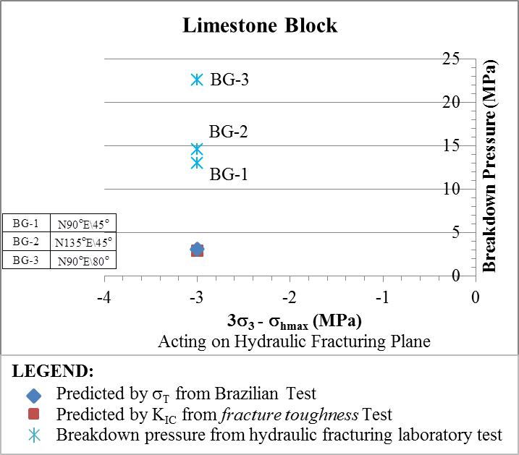

Fig. 1. Prediction of breakdown pressure (modified from Guo, et.al., 1993)

* Paper size: A4
* Line spacing: 14PT
* Margins: Top 35 mm, Bottom 35 mm, Left 30 mm, Right 30 mm, Headliner 0, Footnote 0

